

CALIFORNIA STATE UNIVERSITY, EAST BAY

STAT 6610 DATA VISUALISATION

WINTER 2018

PROJECT 2

SUBMITTED BY:

Nikita Dhok

WJ3449

Sanjana Sugganahalli Mariswamy Gowda

DH2223

PREPARED FOR:

PROF. Eric A. Suess

Professor

Department of Statistics and Biostatistics

Table of Contents

INTRODUCTION 3

Story 1 3

Story 2 4

Story 3 5

Story 4 6

Story 5 7

Story 6 9

Infographic 1: 10

Infographic 2: 11

REFERENCES 12

# INTRODUCTION

The story we have chosen to portray in this project is of one of the biggest emerging entertainment industry NETFLIX. We have tried to the best of our abilities to depict the Financial Analysis and growth of the firm over the years. Most of our data is from the website, Yahoo Finance and Morning Star websites. We have also tried to give visual data on the statistics of Netflix and its competitors. Since the firm we chose to work on is a Public firm, we could manage to get the data from all possible sources online. If any visualizations show limitations, it would be only because of the limited data availability.

## Story 1

Data Source: Yahoo Finance

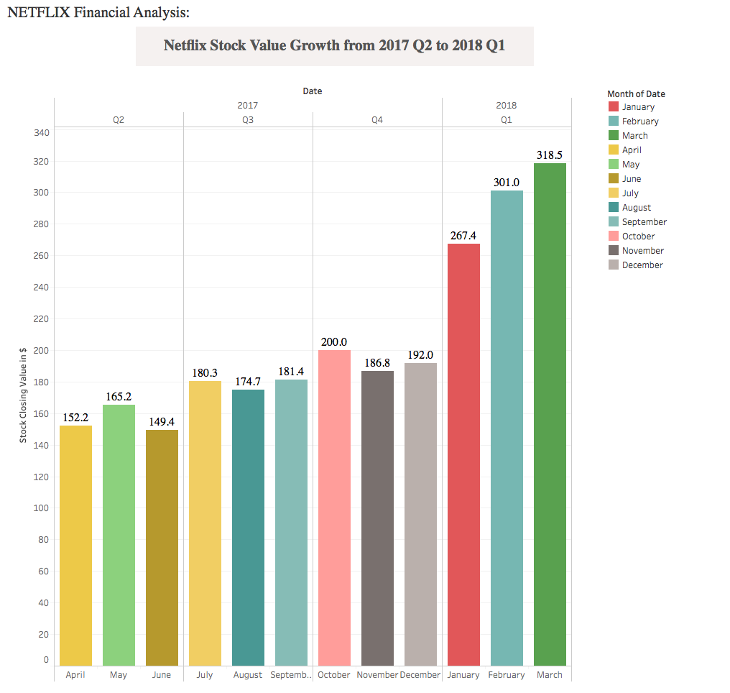

Above visualization shows the stock value growth of Netflix for the last four quarters. Here the variable chosen is the stock closing value for each month in the four quarters. From the visualization we get to see the drastic increase in the firm’s stock value during Q4 of 2017 and current quarter i.e., Q1 of 2018.

## Story 2

Below graph shows the increase in revenue of Netflix from 2013 to 2017. Variables used are revenue vs year.

Data Source: Yahoo Finance

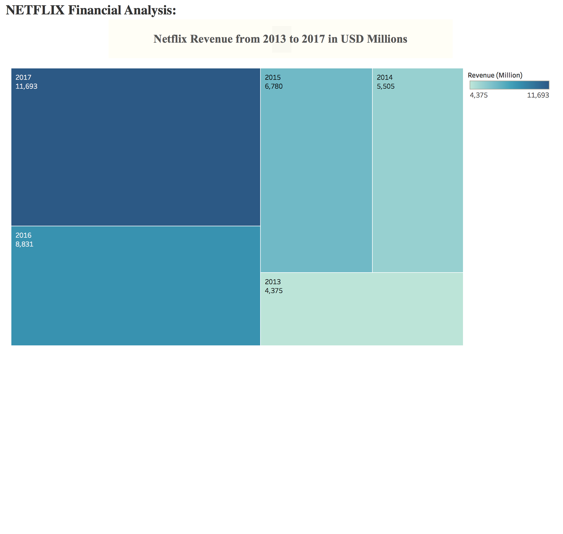

## Story 3

Data Source: Yahoo Finance

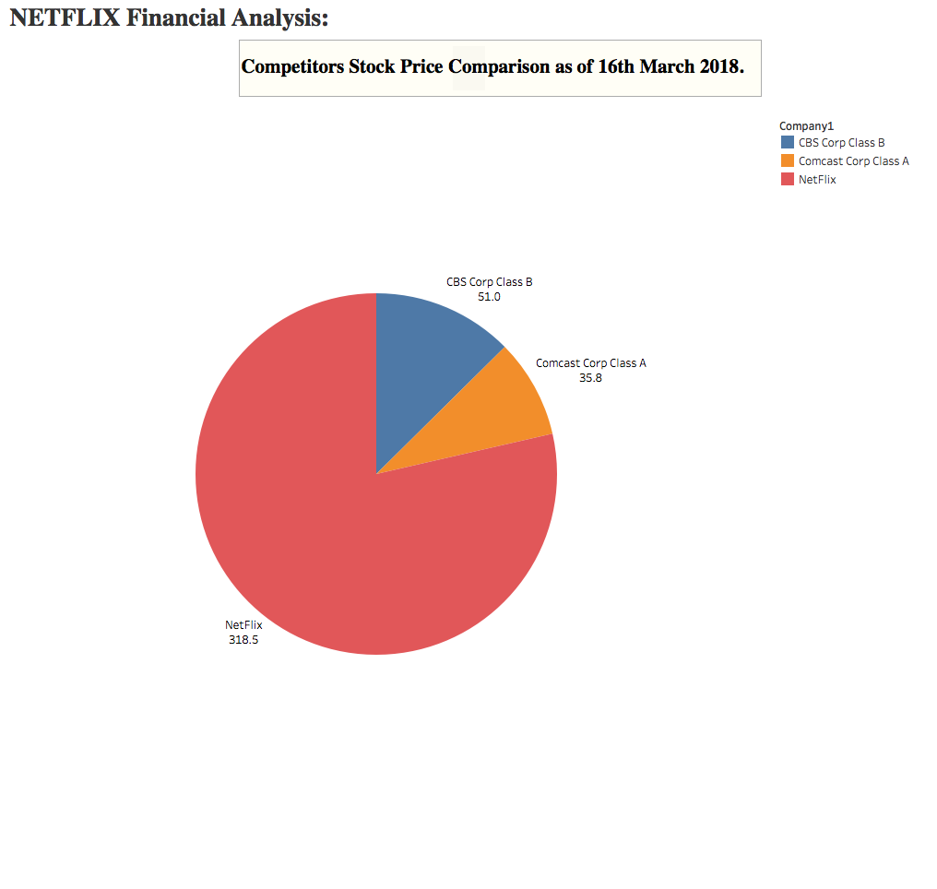

To analyze the value of Netflix’s stock as compared with its competitors, we have made use of a pie chart to show the huge share of its stock value when compared to the two major mass media companies CBS Corp Class B and Comcast Corp Class A.

## Story 4

Data Source: Yahoo Finance

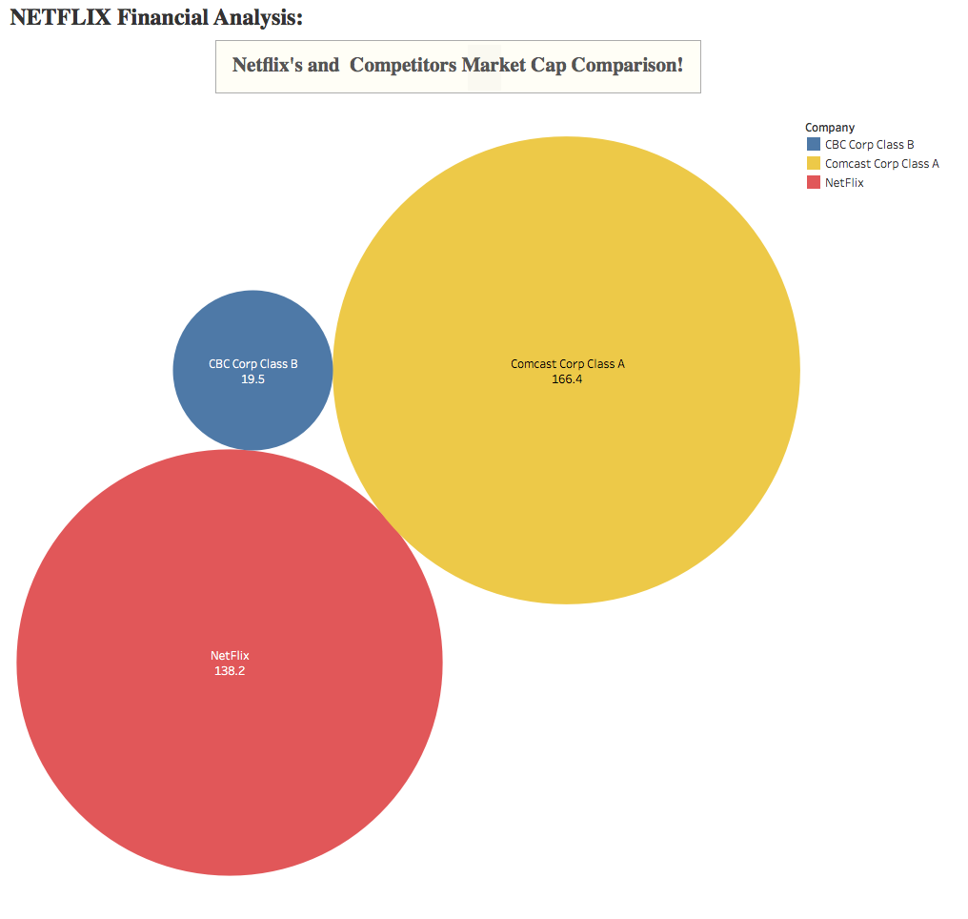

Further continuing the financial analysis of Netflix, we compare the Market Capitalization of the firm with its competitors. From the visualization we understand that Netflix is giving high competition to the Comcast company which is the top most cable service company of the USA. This definitely proves that Netflix is growing bigger than ever as the data seen in the visualization that the difference between the two companies is not too far and with the Netflix’s growth rate it can easily catch up with Comcast and beat it and reach to the top.

## Story 5

Source: <https://help.netflix.com/en/node/14164>

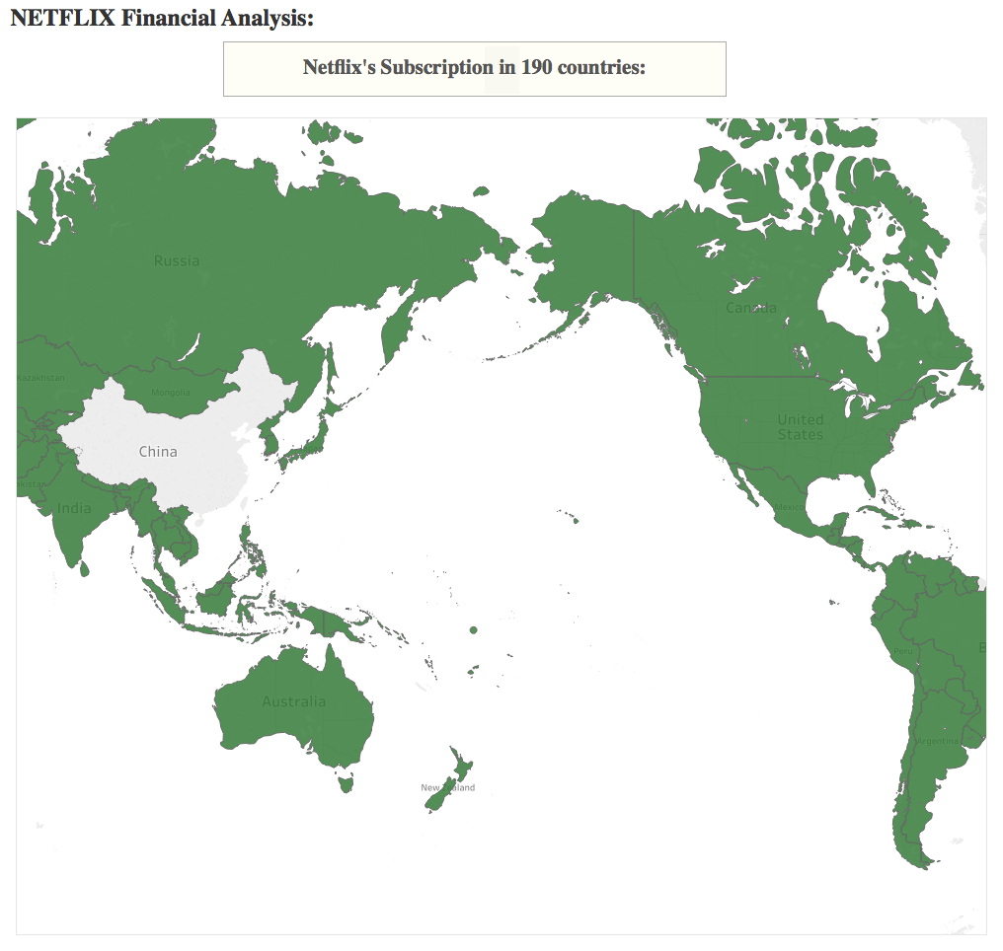

Above geographic visualization shows how widespread the Netflix services are across the world. It spreads to about 190 countries across the world except 3 regions, North Korea, China, and Syria.

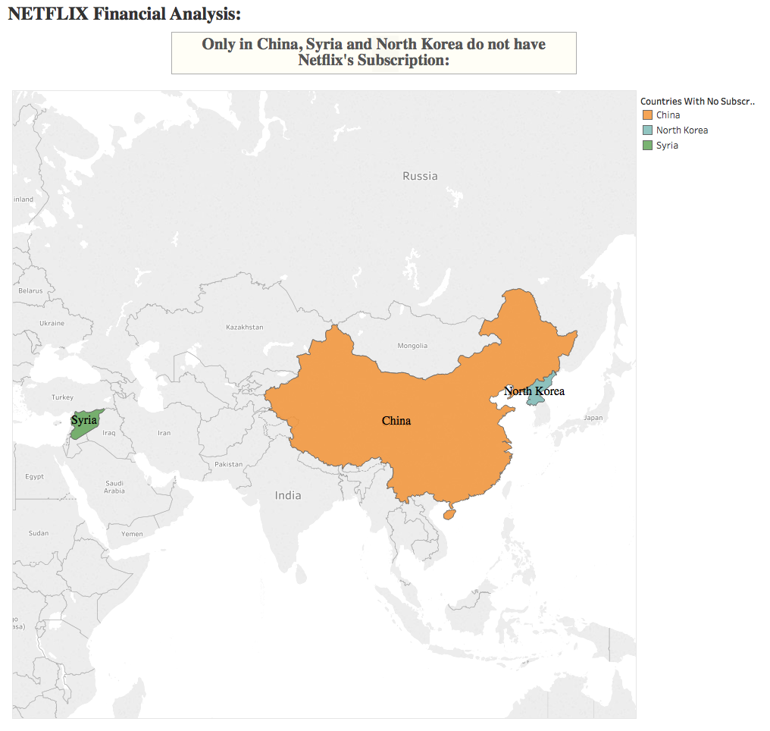

## Story 6

By now, we have enough proof to say that Netflix is world’s leading internet entertainment service company and its performance is highly depended on the best ISP speed to access it.

The Netflix ISP Speed Index lists the average prime time bitrate for Netflix content streamed to Netflix members during a particular month. For ‘Prime Time’, we calculate the average bitrate of Netflix content in megabits per second (Mbps) streamed by Netflix members per ISP.

Speed is measured via all available end user devices.

Below graph depicts the Global averages of Netflix ISP Speed Index.

Data Source: <https://ispspeedindex.netflix.com/global/>

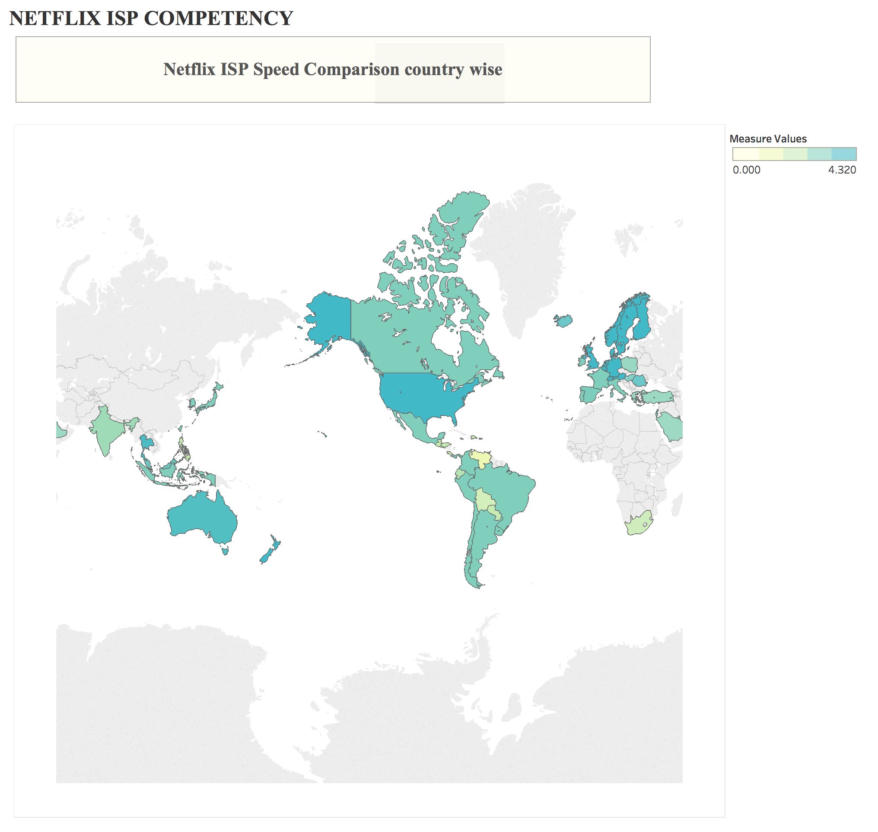

## Infographic 1:

Following is the infographic of the data visualized in the above stories:

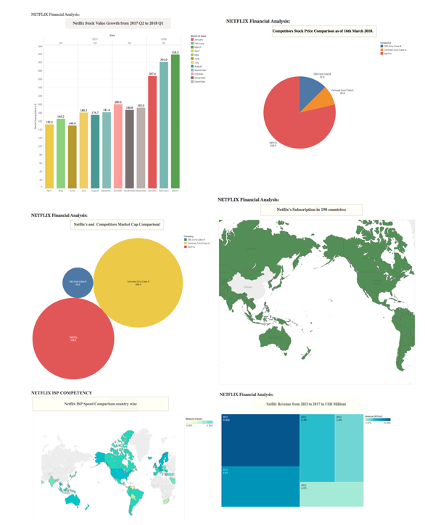

## Infographic 2:

Or similar infographic edited with the help of Google Sheets:

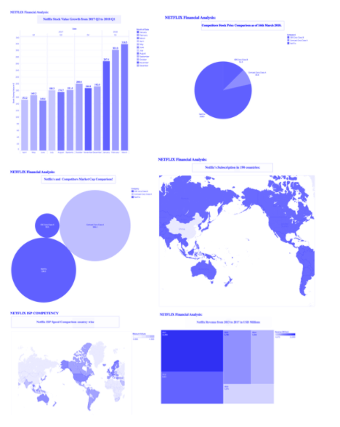

## REFERENCES

<https://ir.netflix.com/static-files/0c060a3f-d903-4eb9-bde6-bf3e58761712>

<https://ispspeedindex.netflix.com/global/>

<https://www.theverge.com/2018/3/15/17123690/amazon-prime-video-audience-numbers-us>

<https://expandedramblings.com/index.php/netflix_statistics-facts/>